**Introduction**

The human ear is divided into the peripheral and central hearing systems. As sound waves travel toward the eardrum, the chain of tiny bones next to it absorb and transfer sound to the inner ear. Hair cells are then used to generate nerve impulses and send information to the auditory cortex. The degree of hearing loss can be measured using an audiometer.

**Method**

For this lab, an audiometer software was made using MATLAB. The code was divided into three sections: introduction, volume calibration, and hearing test. Throughout the test, the user was required to enter basic information and followed the instructions that pop up throughout the test. For volume calibration, a 200 Hz sound was played so that the user could adjust the volume prior to taking the test, which consisted of ten different sounds playing at random frequency and decibel. The user was required to enter yes or no to each sound, and for every yes, a point was plotted on the graph.

**Result**

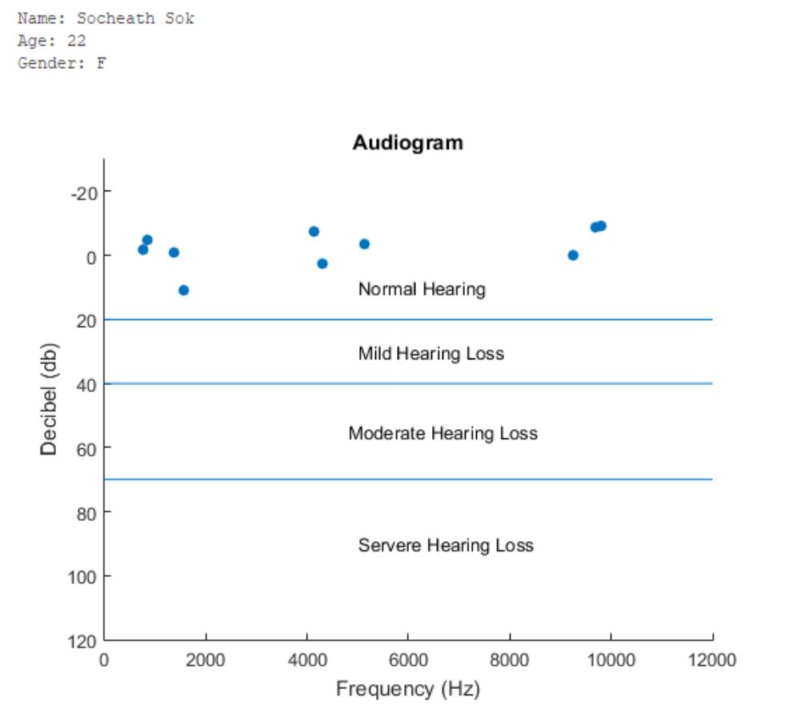

**Discussion.**

The hearing test worked as expected with the final report showing the user’s name, age, and gender. Additionally, all ten points are plotted within the “Normal Hearing” section, so there is little to no hearing loss. Since the sound was generated from the computer and the test was conducted in a non-ideal environment without a proper headphone, the accuracy is low. Moreover, the frequency range was also limited and there was no way to ensure that the loudness of sound was the same for each user, so a lot of improvement is needed for this project.

**Code**



